IoT Dashboard
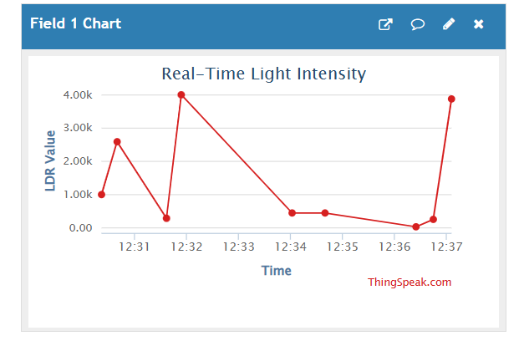

Circuit Diagram
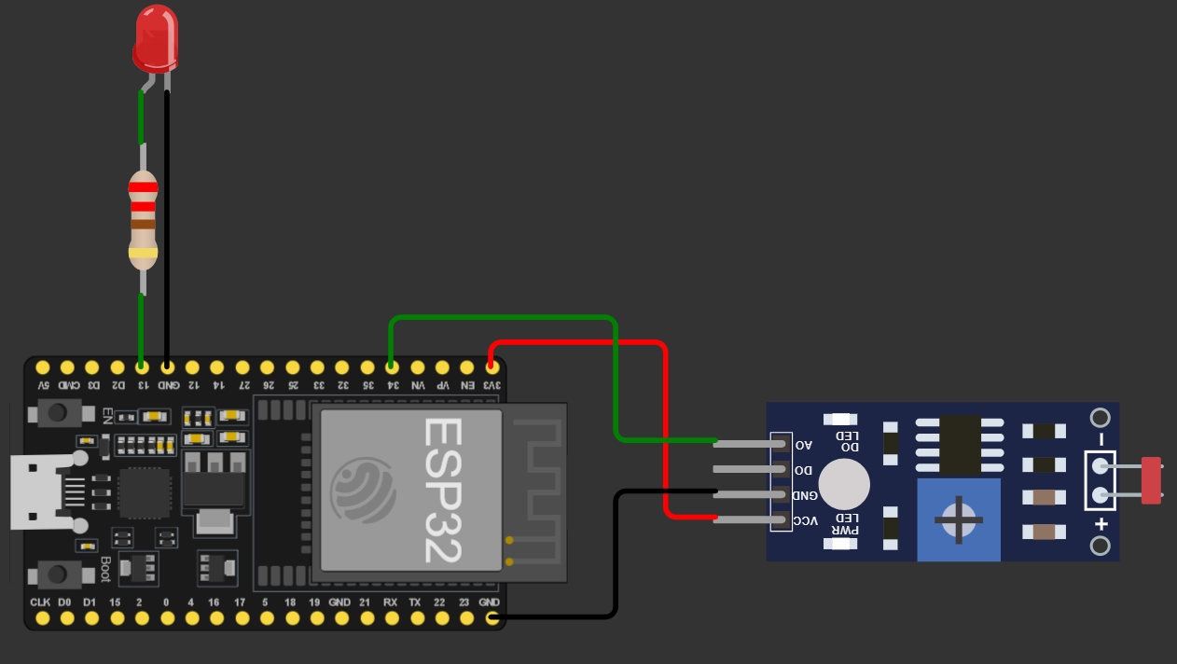

Source Code
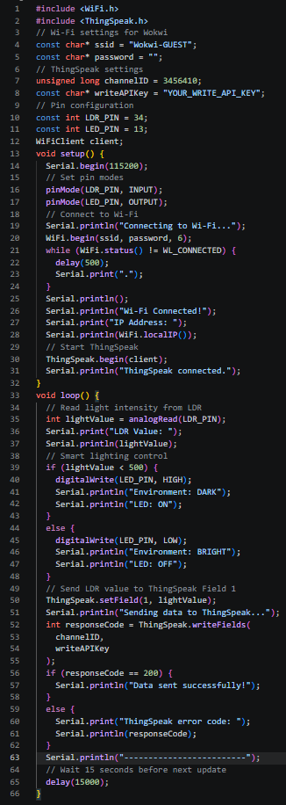
Working Explanation
The Smart Lighting System works by continuously monitoring the surrounding light intensity using an LDR (Light Dependent Resistor) sensor connected to an ESP32 microcontroller. The LDR is a light-sensitive component whose resistance changes according to the amount of light falling on its surface. When the surrounding environment becomes brighter, the LDR produces a different analog value, while in darker conditions, the value changes accordingly. The ESP32 reads this analog signal through its analog input and processes the sensor data using the programmed logic. A predefined threshold value is used to determine whether the environment is bright or dark. If the light intensity falls below the selected threshold, the system identifies the condition as darkness and automatically switches the LED/light ON. When the light intensity increases above the threshold, the system switches the LED/light OFF, helping to reduce unnecessary energy consumption. The ESP32 can also send the collected LDR readings to an IoT monitoring platform through Wi-Fi. The readings are displayed in real time on a dashboard using a graph, where Time is represented on the X-axis and LDR Value on the Y-axis. This allows the user to observe changes in environmental light intensity over time. The system therefore combines light sensing, automatic lighting control, Wi-Fi connectivity, and real-time monitoring in a single IoT-based solution. It can be useful in homes, classrooms, offices, streets, and other smart-city applications where automatic and energy-efficient lighting is required.

